Functional Understanding Document v01

Virtusa  Chennai

karunashraya

Contents

Introduction 3

Req 01 : Volunteering Registration 3

Pre Condition 3

Actors/Users 3

Expected Functionality 3

Post Condition 4

Req 02 : Fund Raising 4

Pre Condition 4

Actors/Users 5

Expected Functionality 5

Fund Raising Registration (offline) 5

Fund Raiding List: 5

Fund Raising Donation and Campaign 6

Post Condition 6

Req 03 : Creating Awareness – Blog and Articles 6

Pre Condition 6

Actors/Users 6

Expected Functionality 6

Screen Shot for Reference 7

Post Condition 7

Req 04 : Social Media 7

Screen Shot 8

Req 05 : Art and Craft 9

Pre Condition 9

Actors/Users 9

Expected Functionality 9

Post Condition 10

Req 06 : Cotton Ball Making 10

Pre Condition 10

Actors/Users 10

Expected Functionality 10

Post Condition 11

Req 07 : Landing Page (Raj) 11

Pre Condition 11

Actors/Users 11

Expected Functionality 11

Screen Shot for reference:- 11

Post Condition 12

Req 08 : Login and Logout Page 12

Req 09 : General Functionality 12

# Introduction

The document explains the Virtusa understanding on the requirements stated by Karunashraya organization. The following diagram explains the UI App model we are planning to design and build.

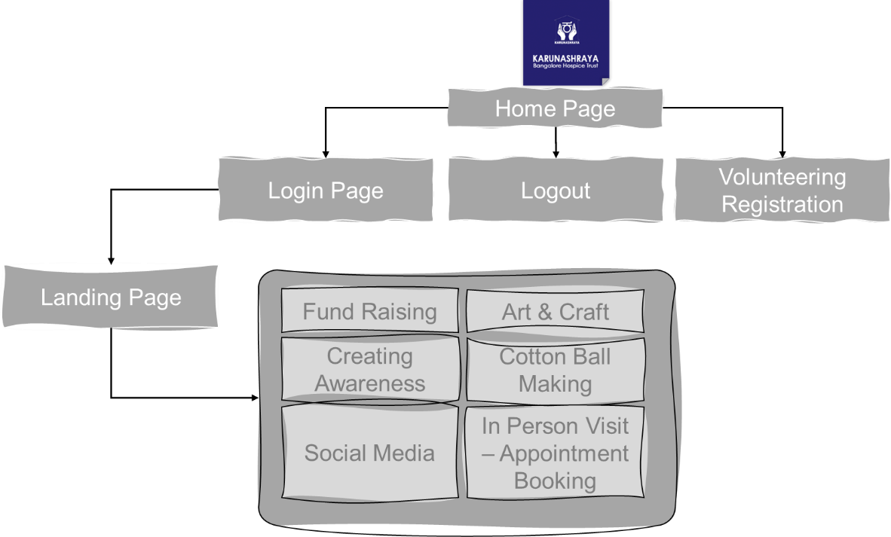

Figure 1: UI Application Flow

# Req 01 : Volunteering Registration

## Pre Condition

None

## Actors/Users

No Restrictions, any one who are willing to volunteer can access

## Expected Functionality

Any one willing to volunteer will perform self registration in the portal, and enter the following fields

|  |  |
| --- | --- |
| Personal Details | |
| First Name  Required | Middle Name |
| Last Name  Required | DOB  Required  Max 21 Years |
| Email address(User ID)  Required  Unique | Profile Photo  Required  Max 100 KB |
| Social Connect (Optional) | |
| LinkedIn | Twitter |
| Instagram | Facebook |
| Contact Details | |
| Contact Number 1 (Mobile)  Required | Contact Number 1 (Land-Line) |
| Address 1  Required | Address 2  Required |
| Address 3  Required | Street  Required |
| State  Required | City  Required |
| Country  Required | PinCode / Zip Code  Required |
| Areas of Volunteering (at least 2 Required) | |
| Cotton Ball | Art and Craft |
| Social Media | Creating Awareness |
| Fund Raising |  |
| In Person Visit | |
| Charity Shop Support | Ambience Maintenance |
| Kitchen Work | Administrative Work |
| Housekeeping | Week Days Available? |
| Week End Available? | Time Preference? |
| Creds | |
| Password  Required | Confirm Password  Required |

## Post Condition

* Success full storage of volunteering details in the system
* No duplicate registrations are allowed
* In case of the existing registered users wants to add additional volunteering activities, the system will provide option to fetch & update the registration information based on the KarId, and can add additional details.
* Creation of unique volunteer UserId(Email), Password
* SMS and Email Alerts
  + To karunashraya admin
  + To registered Volunteer
* The user status in the back end database will be disabled by default. Need karunashraya admin is approve the same activate the volumeter account.
* Team/Staff from Karunashraya, will touch base with registered Volunteers (based on their preferences) and provide further guidance & orientation process.

# Req 02 : Fund Raising

## Pre Condition

* Only registered volunteered users can able to access this module
* Fund Raising setup would be done in any one of the platforms by Karunashraya team
  + Keto
  + Milaap
  + Impactguru
* Assumptions :-
  + The system as such will not handle any fund raising modules, rather it will redirect the logged in user to the pre-configured fund raising platforms.
  + The fund raising platforms will provide required features such as Donation, List of Top Donations, Promoting the fund raising campaign etc

## Actors/Users

* Volunteering Login into the system using registered KarId and Password
* Upon selecting the Fund Raising Link, on the main menu

## Expected Functionality

* The system will display the top 3 fund raising programs.
* The user will have an option to search for a one, & proceed with the same.
* Upon clicking, the user will be re-directed to fund raising platform page

## Fund Raising Registration (offline)

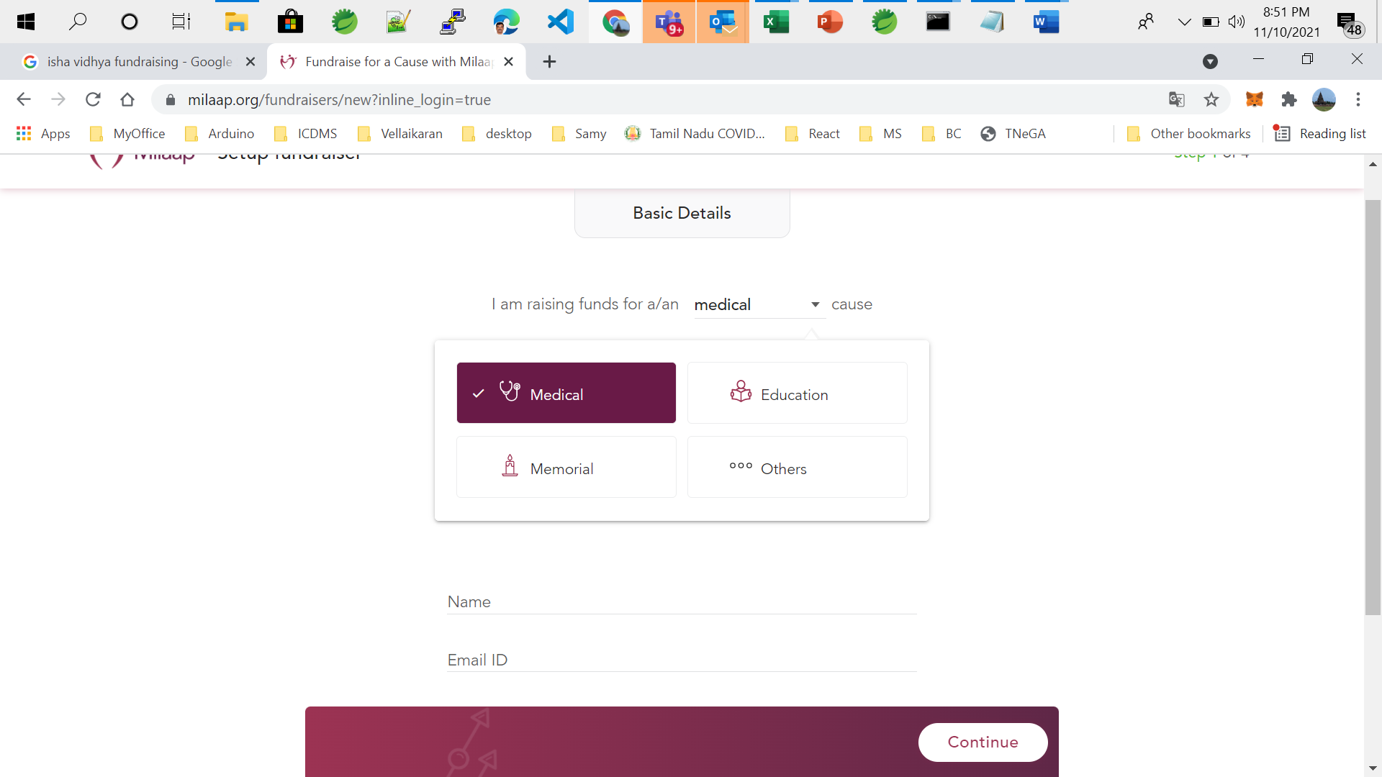

### Fund Raiding List:

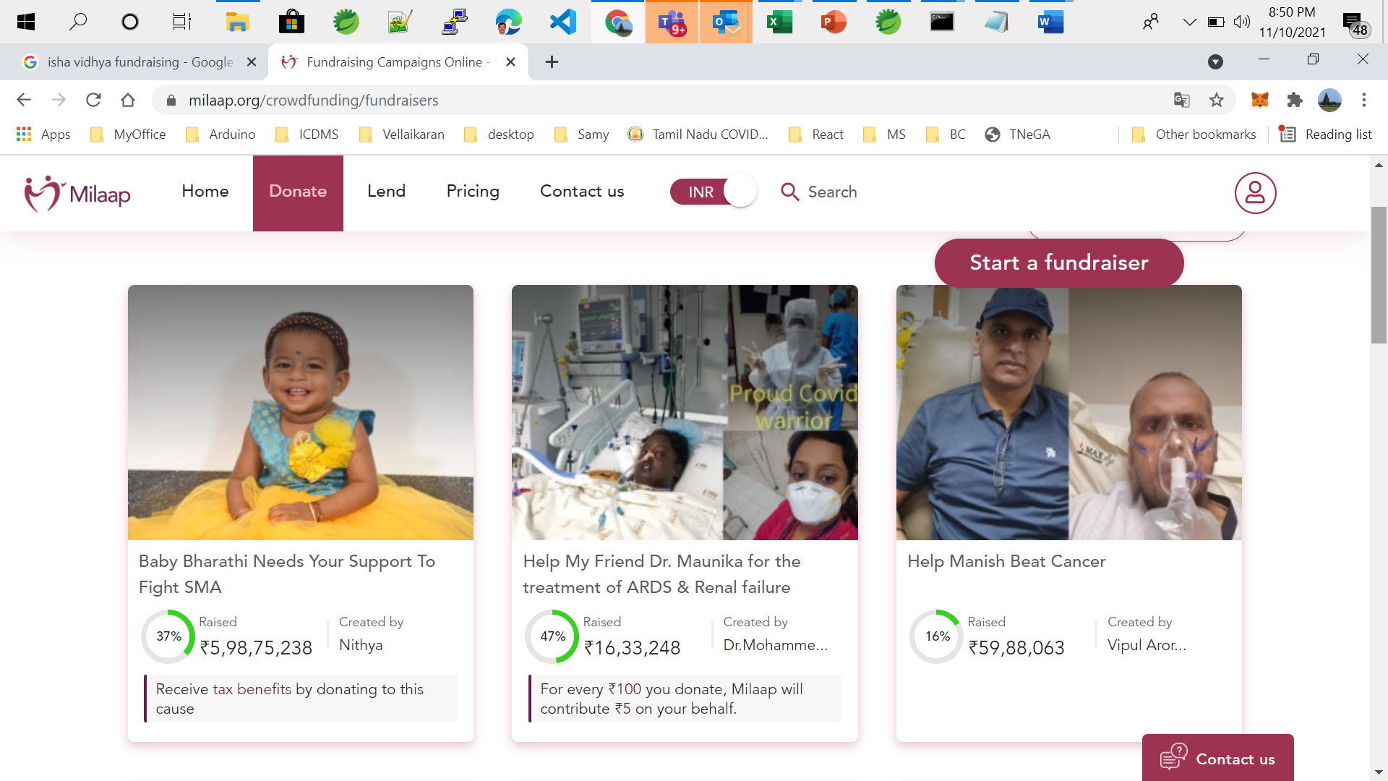

### Fund Raising Donation and Campaign

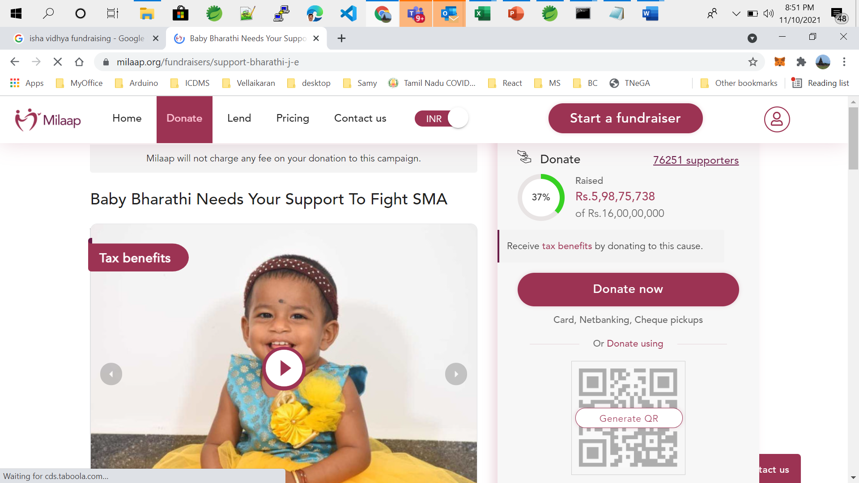

## Post Condition

* The Volunteers could able to donate and participate in fund raising

# Req 03 : Creating Awareness – Blog and Articles

## Pre Condition

* Only registered volunteered users can able to access this module
* Assumptions
  + External Blogger sites will be embedded into the portal using iframe kind of options.

## Actors/Users

* Volunteering Login into the system using registered KarId and Password
* Upon selecting the “Creating Awareness” Link, on the main menu

## Expected Functionality

* The system will display required steps for the logged in user to write & publish blog, articles on sites like blogger.com, Linkedin , Medium ,Tumblr etc

### Screen Shot for Reference

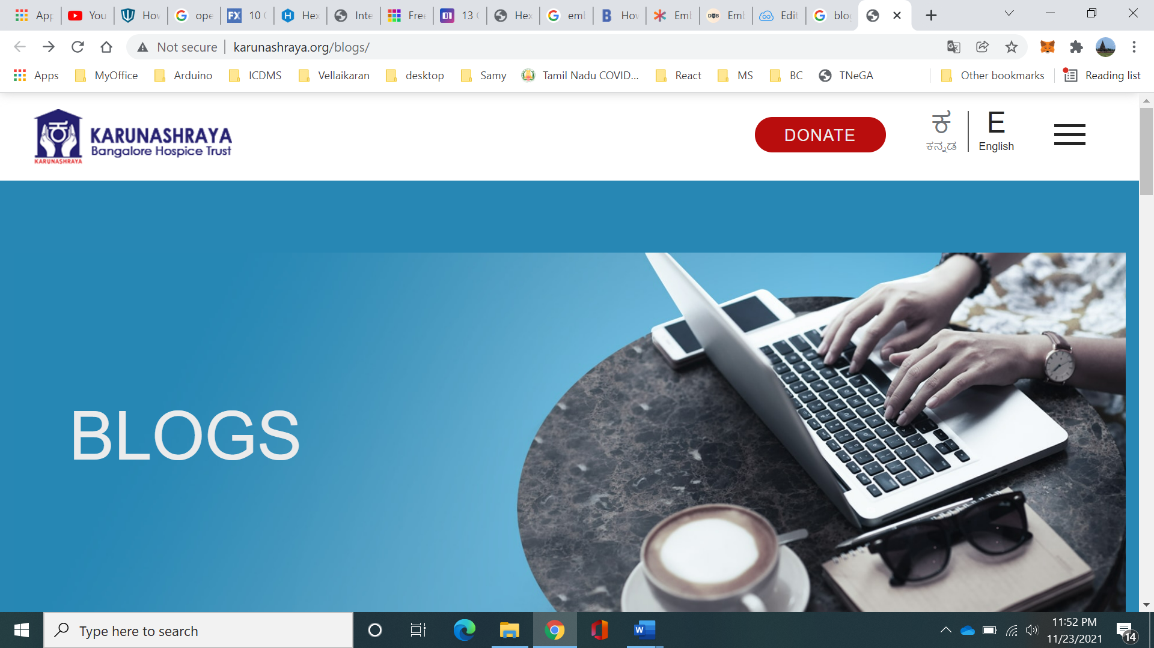]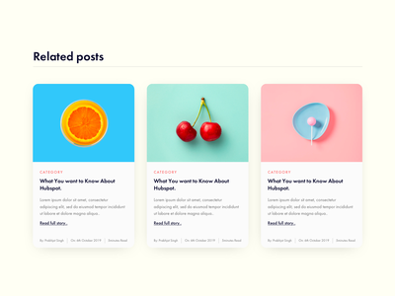

## Post Condition

* The Volunteers could able to create awareness by publishing blogs and articles

# Req 04 : Social Media

Similar to Blog and Articles section, the page will display

* Top trending tweets from/for/by Karunashraya
* The logger in user can able to post and view tweets/fb posts etc

### Screen Shot

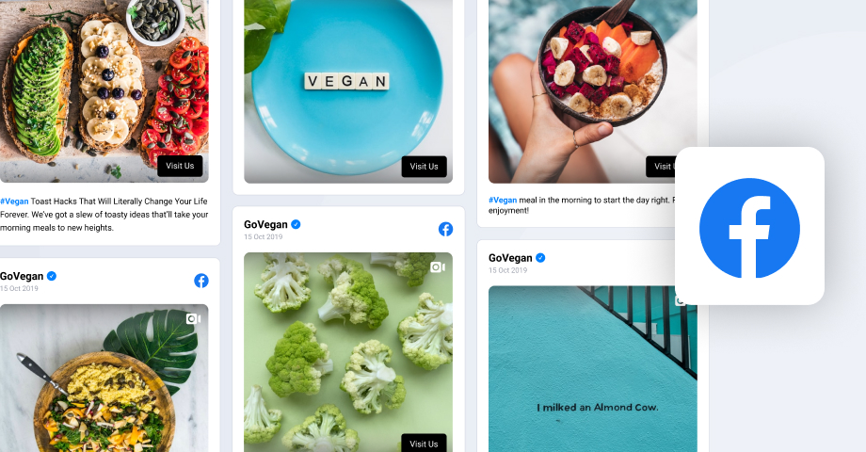

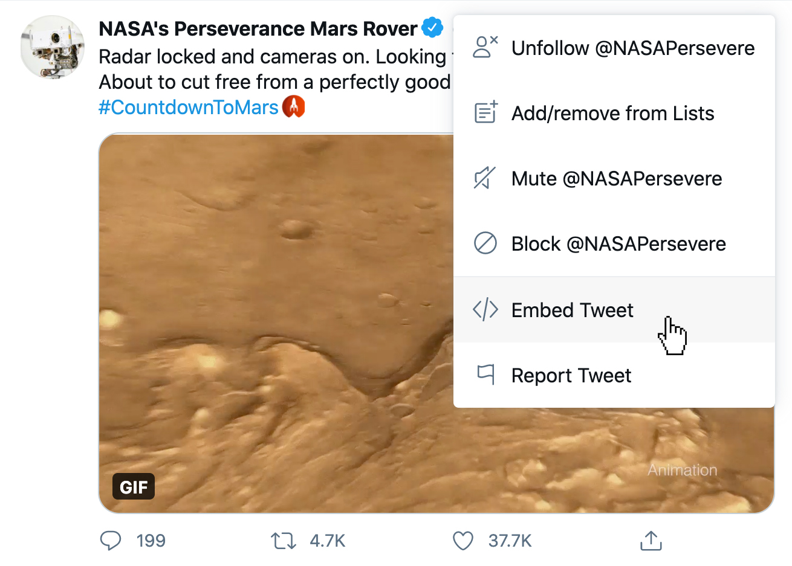

# Req 05 : Art and Craft

## Pre Condition

* Volunteers who have opted for Art and Craft making program.
* Upon selecting the Art & Craft Link, on the main menu

## Actors/Users

* Volunteering Login into the system using registered KarId and Password

## Expected Functionality

* The page captured following details with regards to Art and Craft making
* Page Layout
  + Section 1
    - On going Art and Craft Making Request
    - Shipping (to be updated later upon completion)
      * Date of Shipping
      * Logistics Carrier (fedex, ups, delhivery, dhl etc)
      * Shipping reference number
  + Section 2
    - Type of Arts – Cards, Hand Made Gifts, Toys etc
    - Quantity
    - Completion Date
    - Planned Shipping Date
    - On Submission, a unique reference number will be generated, and the same used for tracking.
  + Section 3
    - Completed and Shipped Arts and Craft activity
  + Info
    - Arts and Craft making Video & Steps
    - Address to send the cotton balls

## Post Condition

Able to Register and ship Arts and Craft balls

# Req 06 : Cotton Ball Making

## Pre Condition

* Volunteers who have opted for Cotton Ball making program.
* Upon selecting the Fund Raising Link, on the main menu

## Actors/Users

* Volunteering Login into the system using registered KarId and Password

## Expected Functionality

* The page captured following details with regards to Cotton Ball making
* Page Layout
  + Section 1
    - On going Cotton Ball Making Request
    - Shipping (to be updated later upon completion)
      * Date of Shipping
      * Logistics Carrier (fedex, ups, delhivery, dhl etc)
      * Shipping reference number
  + Section 2
    - Number of Cotton Balls willing to make
    - Size of Cotton Balls
      * Simple
      * Medium
      * Large
    - Completion Date
    - Planned Shipping Date
    - On Submission, a unique reference number will be generated, and the same used for tracking.
  + Section 3
    - Completed and Shipped Cotton Ball activity
  + Info
    - Cotton Ball making Video & Steps
    - Address to send the cotton balls

## Post Condition

* Able to Register and ship cotton balls

# Req 07 : Landing Page (Raj)

## Pre Condition

* On Successful User login to the system with valid Karid and Password.

## Actors/Users

* All valid used

## Expected Functionality

* Login Details
  + Volunteer Details w user profile
  + Logout option
  + Last login date & time
* On going Volunteering Activity
  + Cotton Balls (Registered, On Going, Completed)
  + Arts and Crafts
  + Social Media
  + Awareness
* On Premises Appointment Status
* General Information,
  + Upcoming events
  + Support Required
* Menu & Sub Menu Generation, and Rendering

### Screen Shot for reference:-

|  |  |
| --- | --- |
|  | |
|  | |
|  |  |

## Post Condition

Able to display dashboard details to the user

# Req 08 : Login and Logout Page

Login using standard username and password & Logout Functionality

1. Upon accessing the login url, the system will display following page
   1. 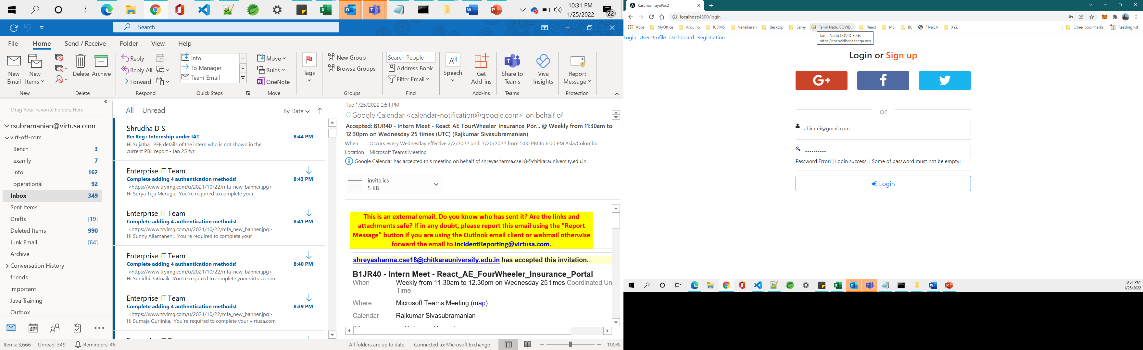
   2. The user can login to the system either via user name password or via Google icon
   3. Upon login using username and password (option 1)
      1. Validate the username and password against the stored value
      2. Upon incorrect match
         1. Show error dialogue
         2. Redirect the user to login page, with error message
         3. Clean up the session storage
      3. Upon correct username and password
         1. The auth response should contain following details
            1. Roles
            2. List of Actions the user/role is mapped to (we should be able to map it to menu generation later)
            3. Firstname
            4. Middle name
            5. Email id
            6. Last logged in time
            7. lastname
            8. Meta Data (part of api response)

IAT

CAT

Access Token

Refresh Token

Uid

* + - * 1. Store the above details in the session storage
        2. Redirect the user to dashboard
    1. Upon selecting Gmail Link, the user enters the gmail credentials to login to the system
       1. The auth response should contain following details
          1. Roles
          2. List of Actions the user/role is mapped to (we should be able to map it to menu generation later)
          3. Query from the user table

Firstname

Middle name

Email id

Last logged in time

lastname

* + - * 1. Meta Data (part of api response)

IAT

CAT

Access Token

Refresh Token

Uid

* + - * 1. Store the above details in the session storage
    1. Redirect the user to dashboard

# Req 09 : General Functionality

|  |  |
| --- | --- |
| Application Logger | Audit Functionality |
| Exception Handling | Swagger API Documentation |
| Unit Testing | API Security |
| Logging | Responsive Functionality |